**CODE:**

subject1 <- c(78,67,89,78)

subject2 <- c(56,78,45,89)

subject3 <- c(67,67,34,58)

marks_summary <- data.frame(subject1,subject2,subject3)

barplot( marks_summary$subject1, xlab= "subject", ylab= "marks")

**OUTPUT:**

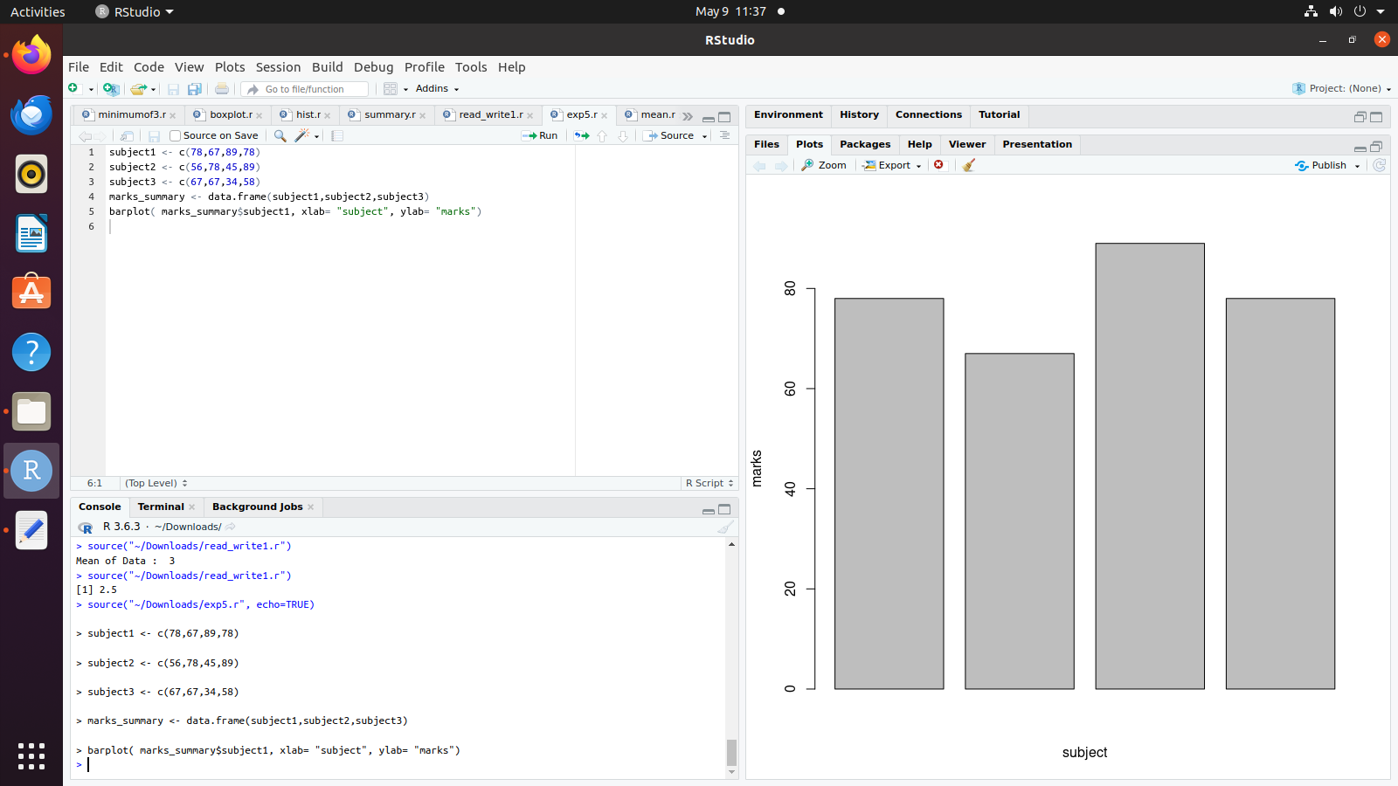

**CODE:**

subject1 <- c(78,67,89,78)

subject2 <- c(56,78,45,89)

subject3 <- c(67,67,34,58)

marks_summary <- data.frame(subject1,subject2,subject3)

barplot(as.matrix(marks_summary),

main="Multiple Bar Plots",

ylab="Count",

beside=TRUE

)

**OUTPUT:**

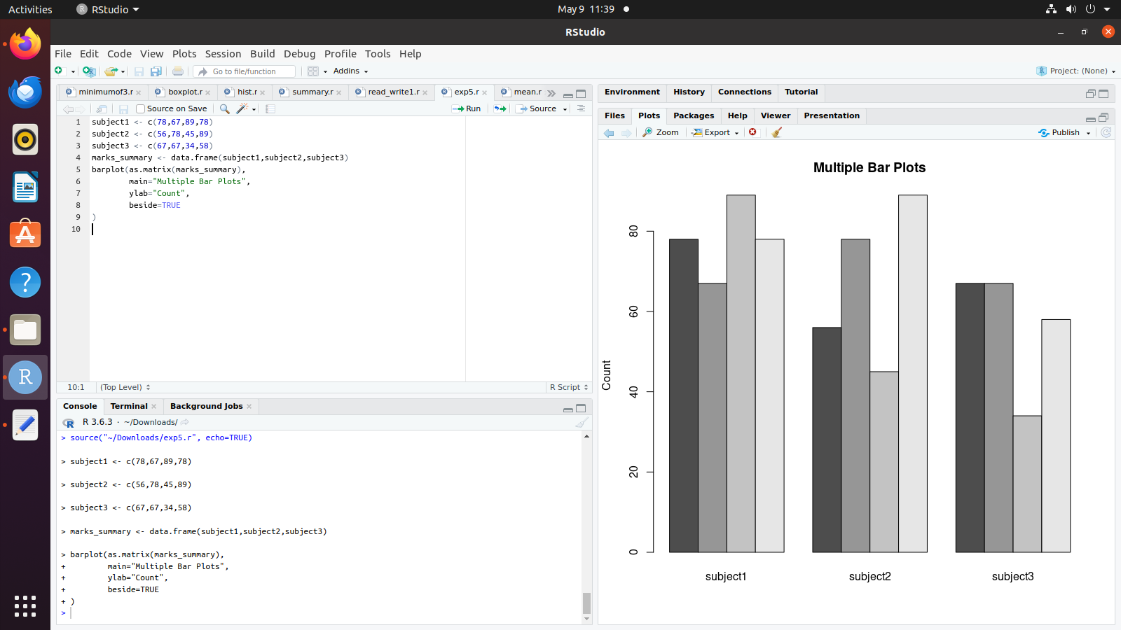

**CODE:**

subject1 <- c(78,67,89,78)

subject2 <- c(56,78,45,89)

subject3 <- c(67,67,34,58)

marks_summary <- data.frame(subject1,subject2,subject3)

boxplot(as.matrix(marks_summary),

main="Multiple box Plots",

ylab="Count",

beside=TRUE

)

**OUTPUT:**

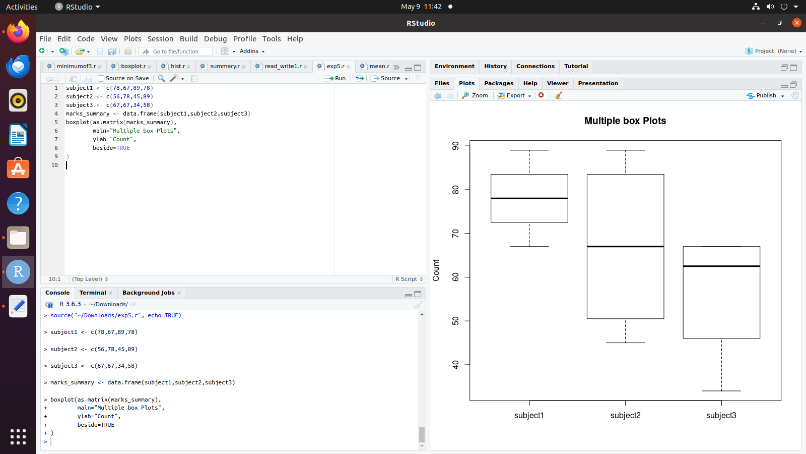

subject1 <- c(78,67,89,78)

subject2 <- c(56,78,45,89)

subject3 <- c(67,67,34,58)

marks_summary <- data.frame(subject1,subject2,subject3)

hist(as.matrix(marks_summary),xlab="subject",col="yellow")

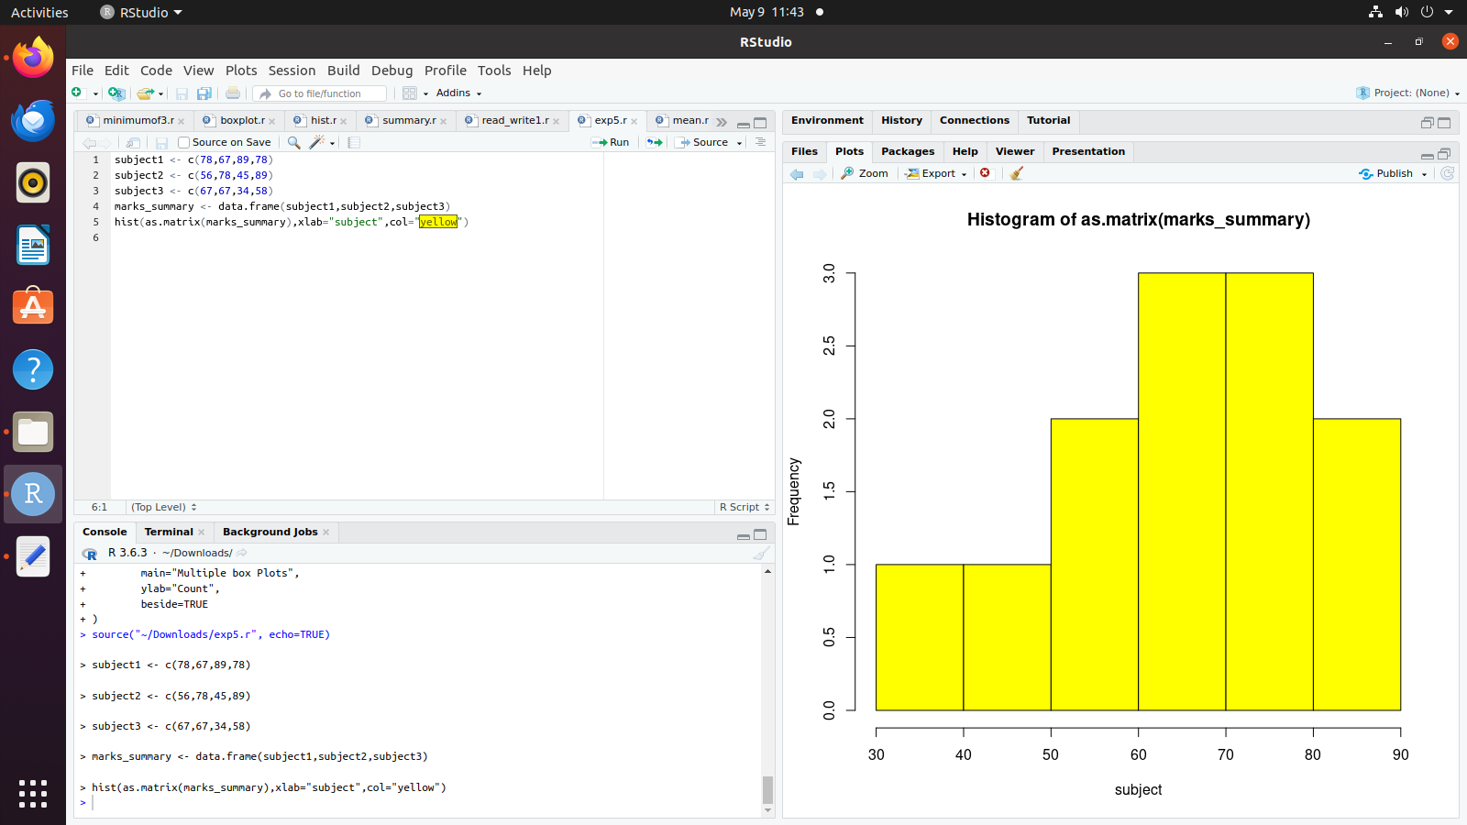

**CODE:**

data("iris")

plot(iris$Sepal.Length,iris$Sepal.Width,

main ="Scatterplot Example",

xlab ="sepal length",

ylab ="sepal width",

col="red")

**OUTPUT:**

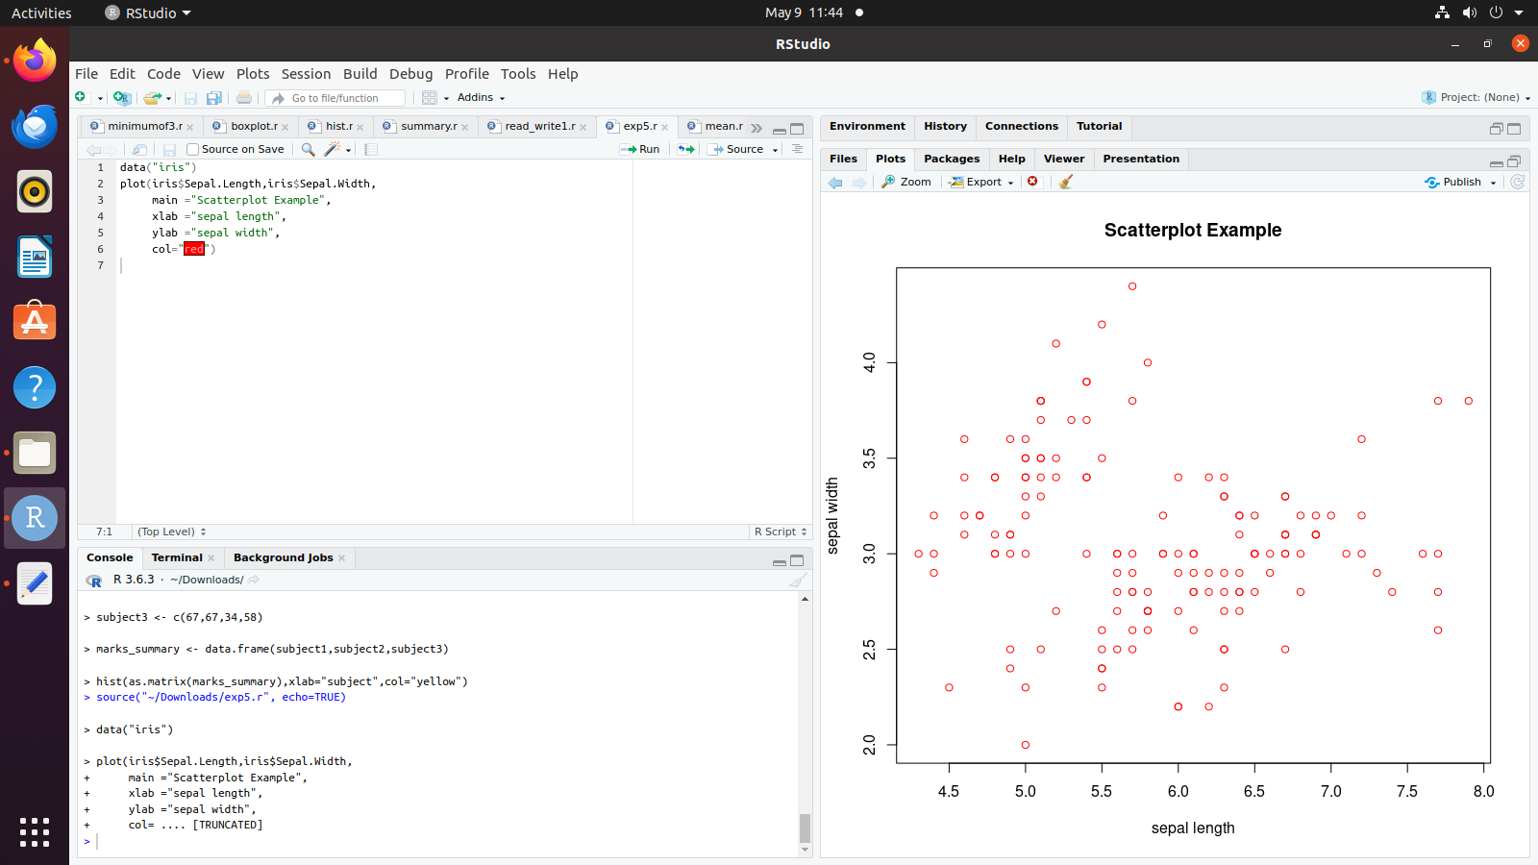

**CODE:**

data("iris")

data1 <- data.frame(Sepal.Length = iris$Sepal.Length, Sepal.Width = iris$Sepal.Width)

library(gplots)

heatmap.2(as.matrix(data1))

**OUTPUT:**

